EIND 422/CSCI 477

**Homework 8**

*Due November 5th*

*(30 points)*

**This homework is to be completed in pairs with someone from your project group.**

**You need to submit in D2L 1 copy of the SIMIO file(s) and turn in a hard copy of the report in class. For the report, please use the report template provided in pages 2-4.**

**From the book Simio and Simulation: Modeling, Analysis, Applications:**

* Problem 5-4: Note: Run the simulation model for 10 replications.

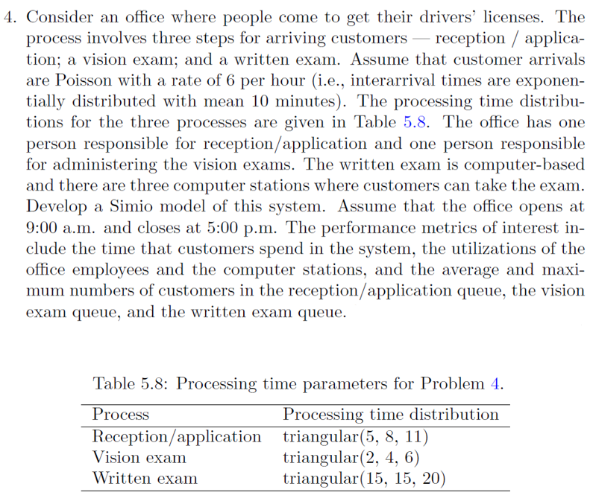

**Homework #: Title** *(0.25)*

Names *(0.25)*

**I. Introduction** *(6)*

1. *(1)* Problem description
2. *(1)* Assumptions
3. *(1)* System initial state- number of entities in the system, # of servers, server status
4. *(1)* Table summarizing the current system inputs. For example:

Table 1- Summary of current system inputs

|  |  |
| --- | --- |
| **Input** | **Value** |
| # Entities to simulate **or** simulation length | Examples:  100 entities  60 minutes |
| # of servers |  |
| Inter-arrival time  Note: 1 row for each entity type | Distribution  Example: Expo(25 min.) |
| Service times  Note: One row for each server class. | Distribution |

1. *(2)*A flowchart or block diagram of the process. For example:



Figure 1- Generic Process flow chart

**Or**



Figure 2- Generic Block Diagram

**II. Methods** *(4)*

1. *(2)* Brief description on how you simulated the problem.
2. *(2)* Include 2 print screens for each SIMIO model; one in 2D and one in 3D. For example:

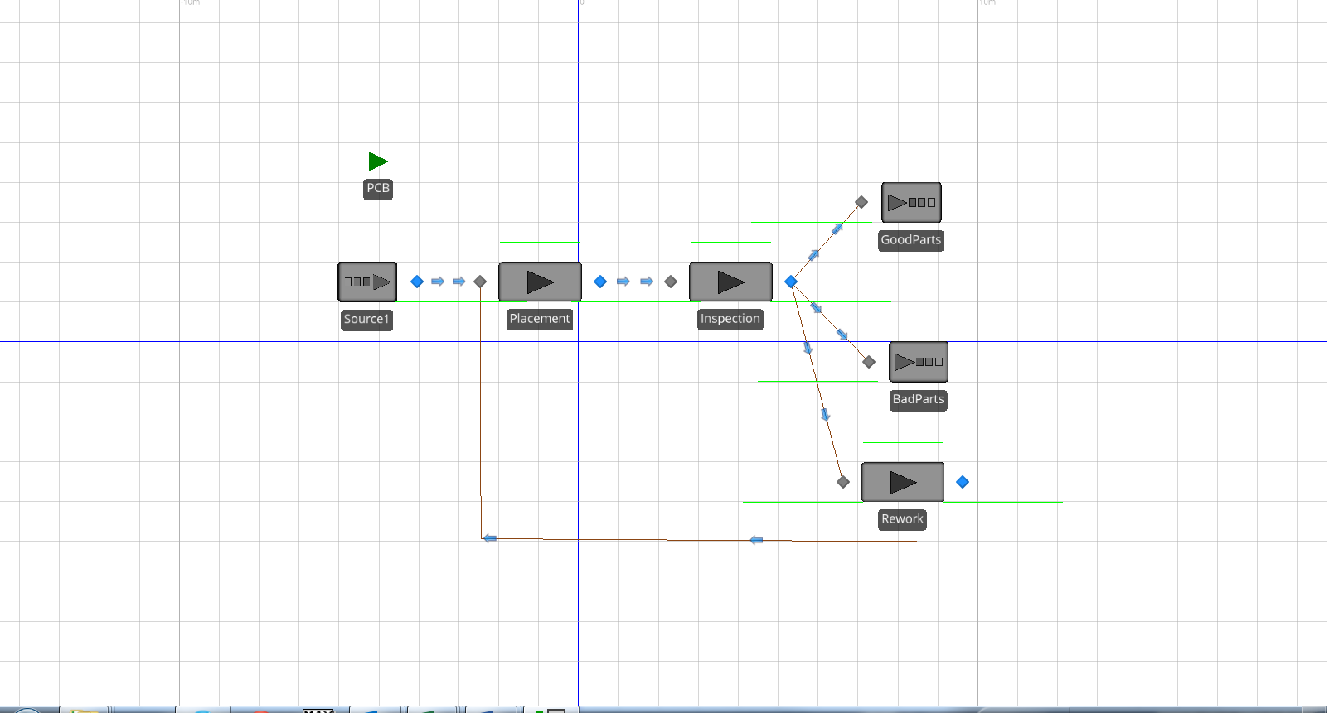

Figure 3- Model 5-2 in 2D

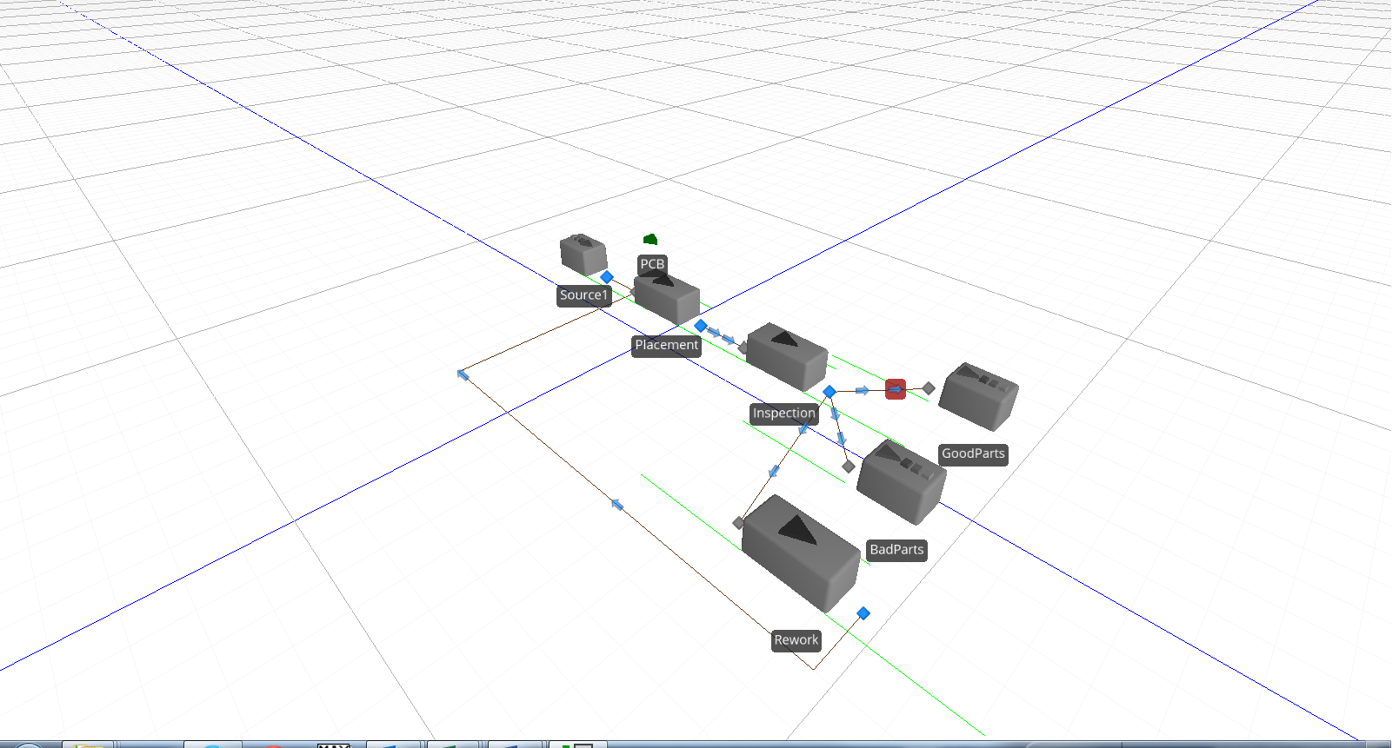

Figure 4- Model 5-2 in 3D

**III. Results** *(9.5)*

* Summarize the outputs ***in your own*** table.

**IV. Discussion** *(6)*

* *(3)* Answer the questions asked.
* *(2)*  Discuss any limitation(s) of the model.
* *(1)* Also, include any comments or observations you might have.

**V. Conclusions** *(4)*

* *(2)* What can you say from the simulation results?
* *(2)* If you were a consultant, what recommendations would you make?

**References**

* Include here any reference you used to help you with the problem. For example, you might include the book here. Use the following format:

Books:

Montgomery, D.C., (2009) Design and Analysis of Experiments. 7th Ed. John Wiley and Sons, Inc., New York.

Journal articles:

Claudio, D., Zhang, J., and Zhang, Y. (2010) ‘A Simulation Study for a New Hybrid Inventory Control Strategy using Advance Demand Information’, *International Journal of Industrial and Systems Engineering,* Vol. 5, No. 1, pp. 1-19.

**Tables and Figures**

Please note that tables are labeled on top and figures are labeled on bottom. Use only the categories of “table” and/or “figure”. Pictures, diagrams, charts, plots, etc. all fall under the “figures” category.